Exterior Angles
# Source: AI Source: Provided by: [Data Path: Persons Table -> ID Column: 1, Name_En Column: Motasem Essam] -> From: [ChatGPT] on [7/25/2026]
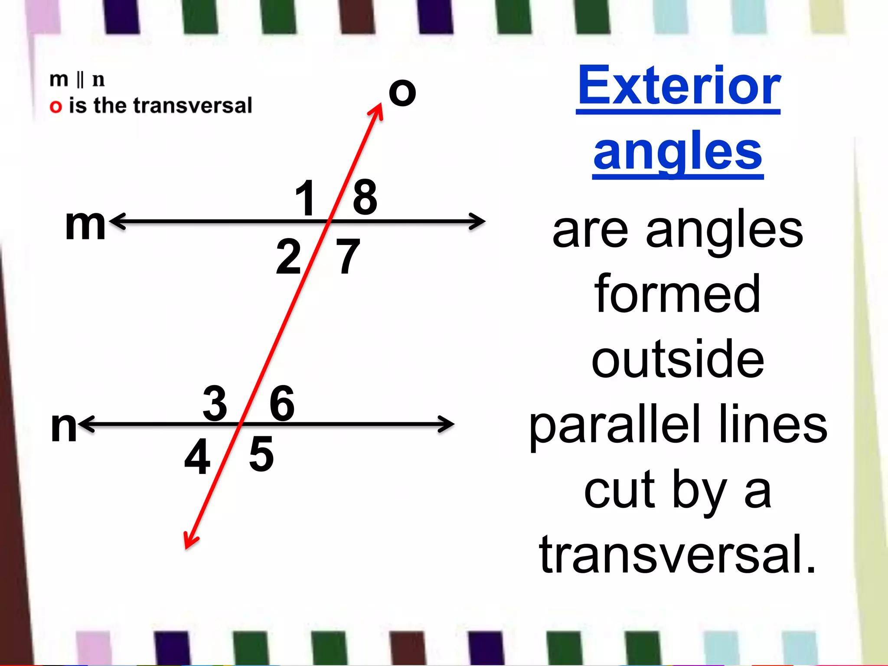
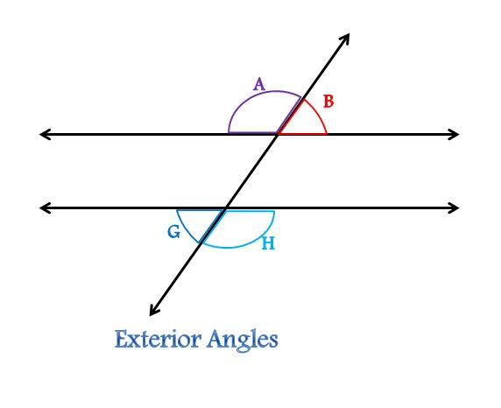
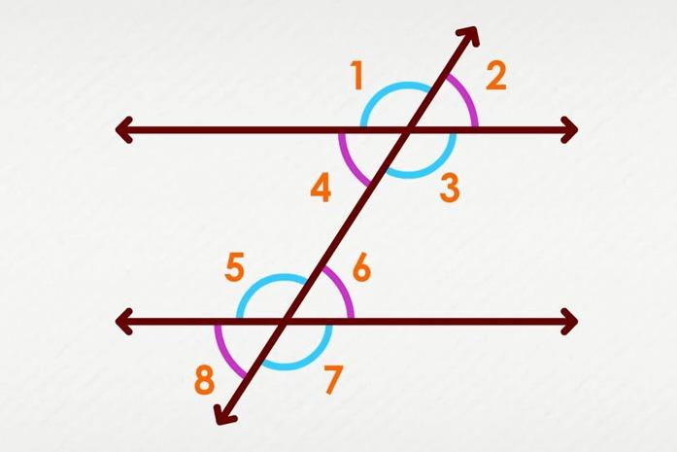
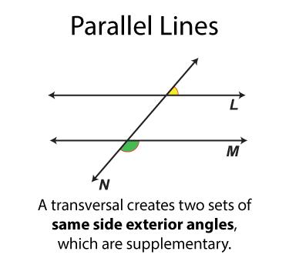
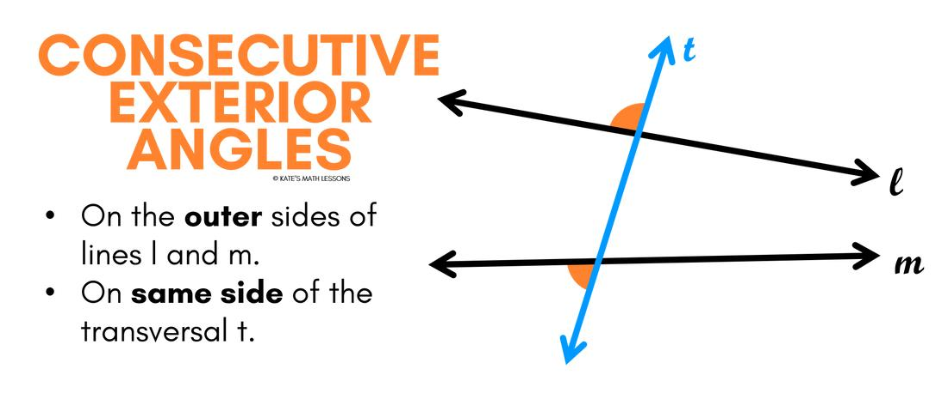

Definition
# Source: AI Source: Provided by: [Data Path: Persons Table -> ID Column: 1, Name_En Column: Motasem Essam] -> From: [ChatGPT] on [7/25/2026]
Exterior Angles are angles located outside a geometric figure or outside the region between two intersected lines. The meaning depends on the geometric context:
- In polygons, an exterior angle is formed by one side of the polygon and the extension of an adjacent side.
- In parallel-line geometry, exterior angles are the angles that lie outside the two lines when they are intersected by a transversal.

Characteristics
# Source: AI Source: Provided by: [Data Path: Persons Table -> ID Column: 1, Name_En Column: Motasem Essam] -> From: [ChatGPT] on [7/25/2026]
Exterior angles:
- Are located outside a geometric figure or outside two intersected lines.
- Share a common vertex with the figure or intersecting lines.
- Are measured in degrees or radians.
- Have important relationships with interior angles.

Exterior Angles in Polygons
# Source: AI Source: Provided by: [Data Path: Persons Table -> ID Column: 1, Name_En Column: Motasem Essam] -> From: [ChatGPT] on [7/25/2026]
An exterior angle of a polygon is formed by:
- One side of the polygon.
- The extension of an adjacent side.
Illustration
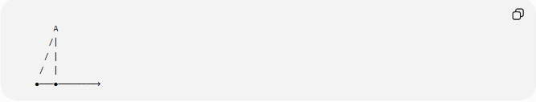
A
/|
/ |
/ |
●───●────────→

The angle formed between the extended side and the adjacent side is an exterior angle.

Exterior Angle and Interior Angle
# Source: AI Source: Provided by: [Data Path: Persons Table -> ID Column: 1, Name_En Column: Motasem Essam] -> From: [ChatGPT] on [7/25/2026]
For every polygon vertex:
$$\text{Interior Angle}+\text{Exterior Angle}={180}^{∘}$$
Therefore,
$$\text{Exterior Angle}={180}^{∘}-\text{Interior Angle}$$

Sum of Exterior Angles of a Polygon
# Source: AI Source: Provided by: [Data Path: Persons Table -> ID Column: 1, Name_En Column: Motasem Essam] -> From: [ChatGPT] on [7/25/2026]
The sum of one exterior angle at each vertex of any polygon is always:
$${360}^{∘}$$
regardless of the number of sides.

Examples
# Source: AI Source: Provided by: [Data Path: Persons Table -> ID Column: 1, Name_En Column: Motasem Essam] -> From: [ChatGPT] on [7/25/2026]
Triangle
Interior angle:
$${70}^{∘}$$
Exterior angle:
$${180}^{∘}-{70}^{∘}={110}^{∘}$$
The three exterior angles satisfy:
$${110}^{∘}+{130}^{∘}+{120}^{∘}={360}^{∘}$$

Square
Each interior angle:
$${90}^{∘}$$
Each exterior angle:
$${90}^{∘}$$
Total:
$$4×{90}^{∘}={360}^{∘}$$

Exterior Angles Between Parallel Lines
# Source: AI Source: Provided by: [Data Path: Persons Table -> ID Column: 1, Name_En Column: Motasem Essam] -> From: [ChatGPT] on [7/25/2026]
When a transversal intersects two lines, the exterior angles are the angles located outside the two lines.


1 2
──────────────
\
\
──────────────
3 4
Angles:
$$∠1,∠2,∠3,∠4$$
are exterior angles.
These angles form special relationships such as:
- Alternate Exterior Angles
- Corresponding Angles

Mathematical Representation
# Source: AI Source: Provided by: [Data Path: Persons Table -> ID Column: 1, Name_En Column: Motasem Essam] -> From: [ChatGPT] on [7/25/2026]
Polygon Exterior Angle
$$E={180}^{∘}-I$$
where:
- $E$ = exterior angle
- $I$ = interior angle

Sum of Exterior Angles
$$\sum{E}={360}^{∘}$$

Properties
# Source: AI Source: Provided by: [Data Path: Persons Table -> ID Column: 1, Name_En Column: Motasem Essam] -> From: [ChatGPT] on [7/25/2026]
Exterior angles:
- Lie outside a polygon or outside two intersected lines.
- Together with the adjacent interior angle form a linear pair.
- Around an entire polygon always total:
$${360}^{∘}$$
- Help determine polygon angle measures.

Relationship with Interior Angles
# Source: AI Source: Provided by: [Data Path: Persons Table -> ID Column: 1, Name_En Column: Motasem Essam] -> From: [ChatGPT] on [7/25/2026]
Every exterior angle and its adjacent interior angle satisfy:
$$I+E={180}^{∘}$$
Example:
Interior:
$${120}^{∘}$$
Exterior:
$${60}^{∘}$$

Real-World Examples
# Source: AI Source: Provided by: [Data Path: Persons Table -> ID Column: 1, Name_En Column: Motasem Essam] -> From: [ChatGPT] on [7/25/2026]
Exterior angles appear in:
- Road intersections.
- Roof edges.
- Building corners.
- Polygonal tiles.
- Bridge frameworks.
- Engineering blueprints.
- CAD models.

Applications
# Source: AI Source: Provided by: [Data Path: Persons Table -> ID Column: 1, Name_En Column: Motasem Essam] -> From: [ChatGPT] on [7/25/2026]
Exterior angles are used in:
- Plane Geometry
- Polygon Geometry
- Coordinate Geometry
- Engineering
- Architecture
- Construction
- Surveying
- CAD (Computer-Aided Design)
- Robotics
- Computer Graphics

Advantages
# Source: AI Source: Provided by: [Data Path: Persons Table -> ID Column: 1, Name_En Column: Motasem Essam] -> From: [ChatGPT] on [7/25/2026]
Studying exterior angles helps to:
- Find missing interior angles.
- Analyze polygons.
- Solve geometric proofs.
- Understand angle relationships.
- Design geometric structures.

Limitations
# Source: AI Source: Provided by: [Data Path: Persons Table -> ID Column: 1, Name_En Column: Motasem Essam] -> From: [ChatGPT] on [7/25/2026]
Exterior-angle properties depend on the geometric context:
- In polygons, the total exterior-angle sum is always:
$${360}^{∘}$$
- Between parallel lines, exterior-angle relationships depend on whether the lines are parallel.

Comparison with Related Concepts
# Source: AI Source: Provided by: [Data Path: Persons Table -> ID Column: 1, Name_En Column: Motasem Essam] -> From: [ChatGPT] on [7/25/2026]
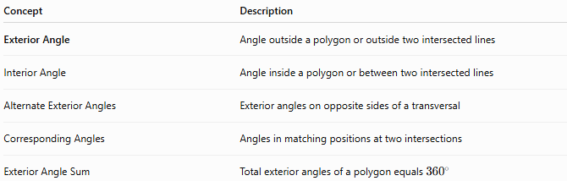
Concept | Description
Exterior Angle | Angle outside a polygon or outside two intersected lines
Interior Angle | Angle inside a polygon or between two intersected lines
Alternate Exterior Angles | Exterior angles on opposite sides of a transversal
Corresponding Angles | Angles in matching positions at two intersections
Exterior Angle Sum | Total exterior angles of a polygon equals (360^\circ)

Key Points
# Source: AI Source: Provided by: [Data Path: Persons Table -> ID Column: 1, Name_En Column: Motasem Essam] -> From: [ChatGPT] on [7/25/2026]
- Exterior Angles are located outside a polygon or outside two intersected lines.
- For polygons:
$$\text{Interior Angle}+\text{Exterior Angle}={180}^{∘}$$
- The sum of one exterior angle at each vertex of any polygon is:
$${360}^{∘}$$
- In parallel-line geometry, exterior angles participate in relationships such as alternate exterior angles and corresponding angles.

Conclusion
# Source: AI Source: Provided by: [Data Path: Persons Table -> ID Column: 1, Name_En Column: Motasem Essam] -> From: [ChatGPT] on [7/25/2026]
Exterior Angles are angles located outside a polygon or outside the region between two lines intersected by a transversal. In polygons, each exterior angle is supplementary to its adjacent interior angle, and the sum of one exterior angle at every vertex is always ${360}^{∘}$. In parallel-line geometry, exterior angles form important relationships such as alternate exterior angles and corresponding angles. Exterior angles are fundamental in plane geometry, polygon geometry, coordinate geometry, engineering, architecture, construction, surveying, CAD, robotics, and computer graphics, where they are used to analyze shapes, determine unknown angles, and study line relationships.

